Web Application screenshots for reference

1. All Customers displayed

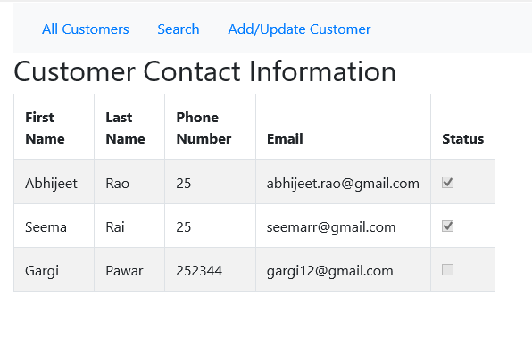

1. Search by first name

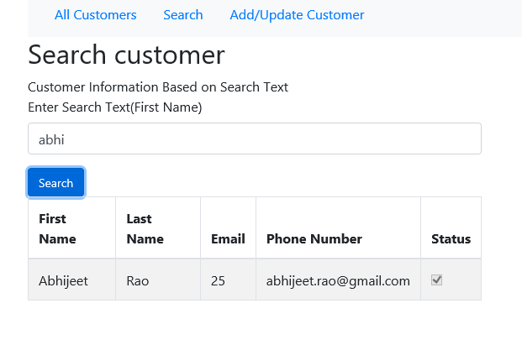

1. Add / Update the details

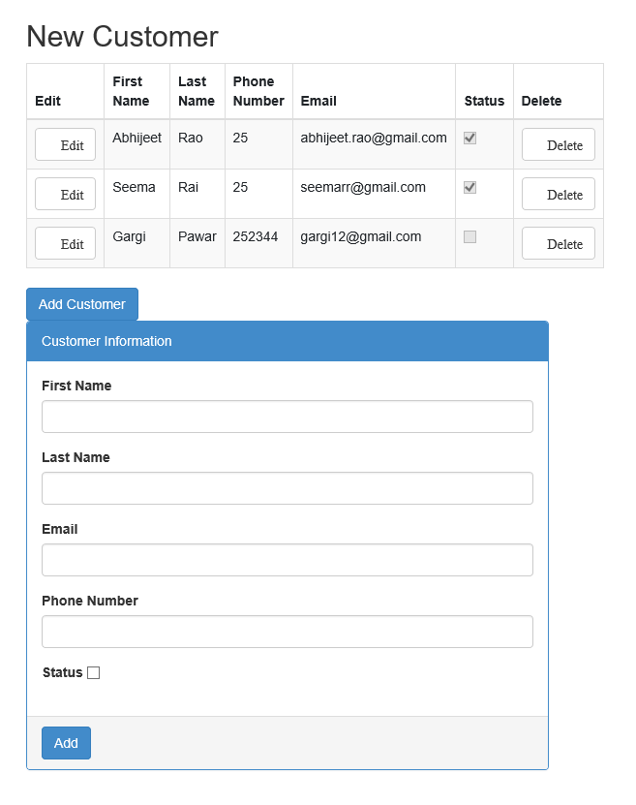

On click of edit, data is displayed which can be edited

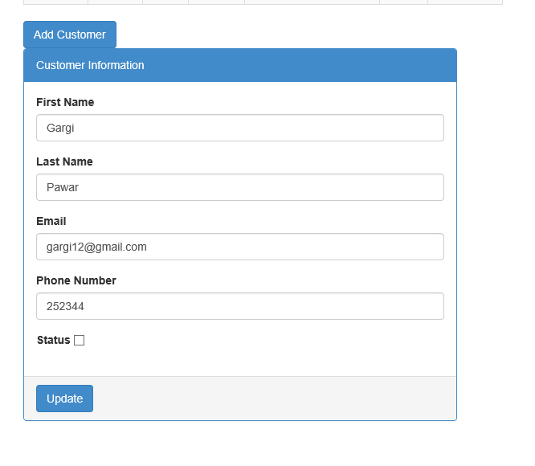

On click of delete data is deleted from the database